**RDA/Chronic OOC AD Instruction**

**Triggering Rule**

* RDA AD Triggering Rule

Currently, for RDA AD, we will query past 24 hours and check whether any new OOC points.

To analyze a chart, below criteria must meet:

* + chart has minimum 1 point within 24 hours
  + chart has minimum 2 OOC points **and** 2 good points in same chart type
  + chart type is mean, sigma, range and ewma-mean.
* Chronic OOC AD Trigger Rule

For chronic ooc AD triggering, we use chronic ooc chart list from SPC team.

* + for multiple chart type highlighted in the Chronic OOC chart list, the chart type with most OOC points will be analyzed by AD

**Data Source**

* SPACE Data
  + AD currently use Global Data Warehouse (GDW) SPACE data source from **hive** table.
    - Databases:
      1. prod_mti_{region}_fab_{fab}_spc_dm
    - Tables:
      1. prod_mti_{region}_fab_{fab}_spc_dm.T_EXT_SAMPLES_VIOL
      2. prod_mti_{region}_fab_{fab}_spc_dm.t_channel_def
      3. prod_mti_{region}_fab_{fab}_spc_dm.t_ext_samples_wafer
      4. prod_mti_{region}_fab_{fab}_spc_dm.t_ext_samples_lot
      5. prod_mti_{region}_fab_{fab}_spc_dm.t_ext_samples_calc
      6. prod_mti_{region}_fab_{fab}_spc_dm.t_channel_def
  + Query Method:
    - PySpark
* Sigma Data
  + AD currently use Global Data Warehouse (GDW) Sigma data source from **hbase** table.
    - Databases:
      1. prod_mti_singapore_fab_10_sigma
      2. prod_mti_singapore_fab_10_autodiagnostic
    - Tables:
      1. prod_mti_singapore_fab_10_sigma:sigma_lot_v2
      2. prod_mti_singapore_fab_10_sigma:sigma_wafer_v2
      3. prod_mti_singapore_fab_10_sigma:sigma_measurement_v2
      4. prod_mti_singapore_fab_10_autodiagnostic:wafer
  + Query Method:
    - Hbase Thrift Server (python)
* SWR Data
  + AD currently use Global Data Warehouse (GDW) SWR data source from **Teradata** table.
    - Databases:
      1. FAB_{fab}_SWR_DM
    - Tables:
      1. FAB_{fab}_SWR_DM.SWR_LOT
      2. FAB_{fab}_SWR_DM.SWR
      3. FAB_{fab}_SWR_DM.SPLIT_DEFINITION
      4. FAB_{fab}_SWR_DM.SPLIT_GROUP
      5. FAB_{fab}_SWR_DM.TRAV_DEF_FOR_GROUP
      6. FAB_{fab}_REF_DM.STEP
      7. FAB_{fab}_SWR_DM.WAFERS_IN_SPLIT
  + Query Method:
    - python
* QDR Data
  + AD currently use Global Data Warehouse (GDW) QDR data source from **Teradata** table.
    - Databases:
      1. FAB_{fab}_QDR_DM
      2. WW_MFG_DM
    - Tables:
      1. FAB_{fab}_QDR_DM.QDR_WAFER
      2. FAB_{fab}_QDR_DM.QDR_TEXT
      3. FAB_{fab}_QDR_DM.QDR_HEAD
      4. WW_MFG_DM.d_Step
  + Query Method:
    - python
* PM/CM Lead Lot Data
  + AD currently use Global Data Warehouse (GDW) QDR data source from **Teradata** table.
    - Databases:
      1. WW_MFG_IDS_DM
      2. WW_MFG_DM
      3. FAB_{fab}_FT_DM
    - Tables:
      1. Obtain pm/cm information
         * WW_MFG_IDS_DM.ET_EVENT_HISTORY
         * WW_MFG_IDS_DM.ET_EQUIPMENT
         * WW_MFG_IDS_DM.ET_EQUIPMENT_state_for_area
         * WW_MFG_IDS_DM.REF_MFG_AREA
         * WW_MFG_IDS_DM.ET_EVENT_CODE_HISTORY
         * WW_MFG_IDS_DM.ET_EVENT_NOTE
      2. Obtain lot information
         * WW_MFG_DM.d_LotStepMES
         * FAB_{fab}_FT_DM.FAB_LOT_HIST
         * FAB_{fab}_FT_DM.FAB_LOT_EQUIP_HIST
  + Query Method:
    - Python
* Lot Attribute Analysis
  + AD currently use Global Data Warehouse (GDW) lot attribute data source from **Teradata** table.
    - Databases:
      1. FAB_{fab}_FREC_DM
      2. FAB_{fab}_REF_DM
      3. WW_MFG_IDS_DM
    - Tables:
      1. Obtain step information
         * FAB_{fab}_FREC_DM.exception
         * FAB_{fab}_FREC_DM.exception_member
         * FAB_{fab}_FREC_DM.attr
         * FAB_{fab}_FREC_DM.process_exception
         * FAB_{fab}_FREC_DM.process
         * FAB_{fab}_REF_DM.step
         * FAB_{fab}_REF_DM.corr_item
      2. Obtain lot information
         * WW_MFG_IDS_DM.FT_FAB_LOT_ATTR_VALUE
         * WW_MFG_IDS_DM.REF_CORR_ITEM
  + Query Method:
    - python

**Analysis**

* FMEA List
  + This feature currently is only available for RDA AD.
* Domain knowledge
  + This feature currently is only available for RDA AD.
* **Feedback (past lesson learnt)**
  + We also added Historical Feedback table in AD report:

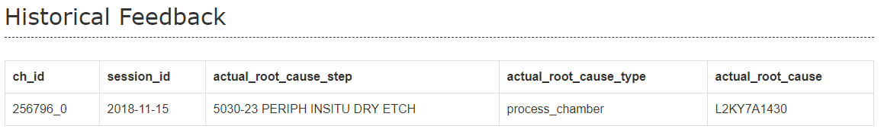

* **Last OOC Check**
* **Weighted Correlation**

**Report**

* Sections
  + The title section is to briefly describe the AD report. For example, the below example shows that the AD report is pertaining to channel 256796, CKC 0, chart type Mean, reference OOC lot id 9595311 and wafer id 5311-23.

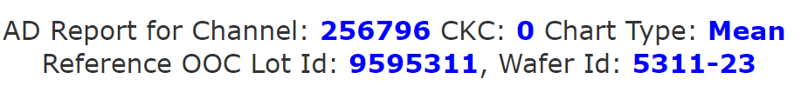

* Report Features
  + Download data

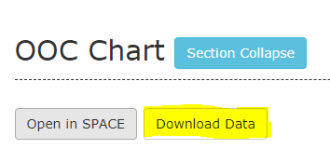

* + Open SPACE link  
    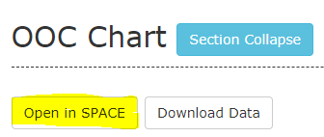
  + Section Collapse  
    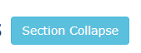
  + Click to Show Plotting Charts
    - Click one row in Result Table

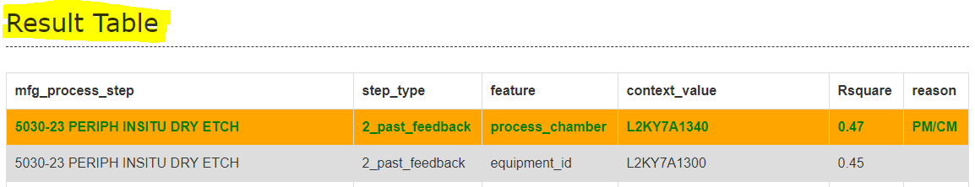

* 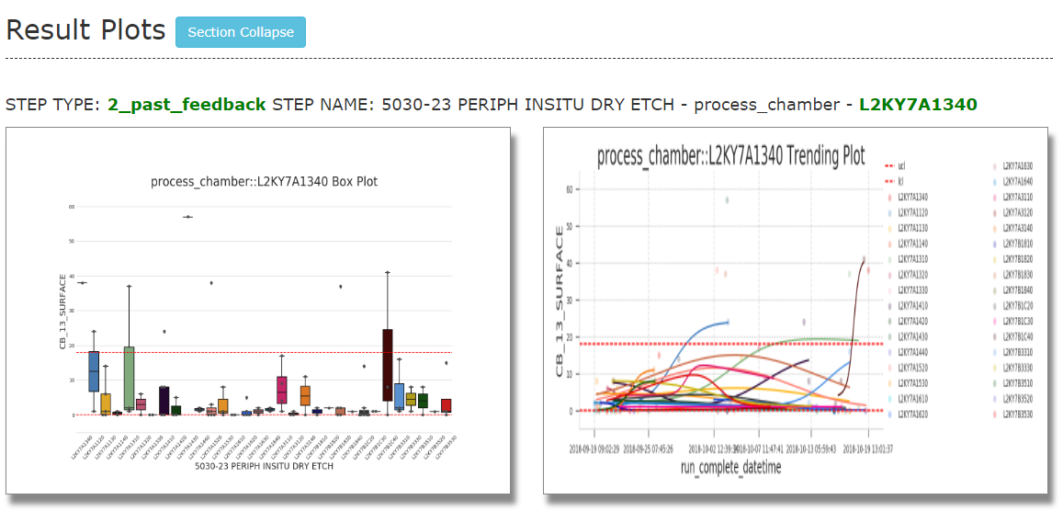Plotting charts will be shown in Result Plots  
  + 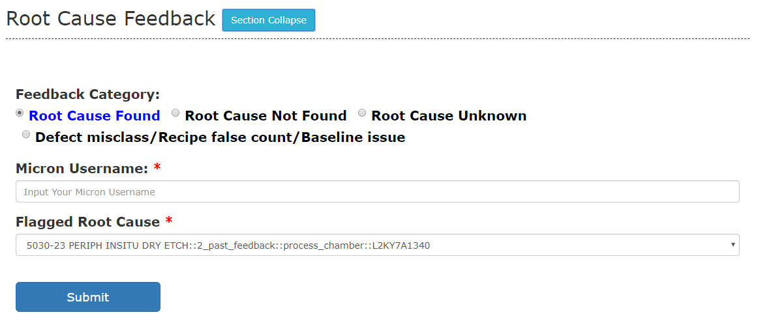Feedback

**Dashboard**

* Tracking Dashboard
* Accuracy Tracking
* Feedback Tracking

**Change Log**

**Future Roadmap**

* Lot Attribute Analysis
* FD Analysis